Website Planning

Pages:

1. Home Page

A New generation for administration!

Say goodbye to the burdens and complexities of rental administration, and bid farewell to the risks of penalties imposed by tightening regulations. At BRE Consulting, we usher in a new generation of efficiency and peace of mind for your business.

With our comprehensive services, we provide the ultimate solution to all your business and administration needs. Imagine being secure in the knowledge that all operations and regulations are meticulously adhered to, ensuring your company's reputation remains sterling in the eyes of investors.

Ready to sleep through an storm?

**Why choose BRE as a partner?**1. Specialization: We specialize in the real estate industry, guaranteeing the necessary focus and experience to make sure your business operates according to all regulations and best practises.

2. Powerhouse team: Your personal Attorney, Auditor, Accounts Manager, Administrator and maintenance manager all united under one roof. Say goodbye to the hassle of comparing between multiple service providers. Experience seamless communication and unparalleled unity across every facet of your business.   
3. Significant cost savings: With our tailored services, experience and strategic partnerships. Experience everything you need at a fraction of the usual expense. No more negotiations required.

4. CRM Expertise: In today's digital age, seizing opportunities is essential. That's why our team possesses extensive expertise in all the top Sales & Rental CRM solutions in the industry. Unsure what software or platform is best for your business? We know them inside out and can help you make informed independent decision.

5. Reduced Risk: Keeping up with regulatory changes can be daunting, as regulatory bodies tighten their oversight and continuously update rules and regulations. Whether it's financial year-end audits or FIC submissions, missing deadlines can incur significant penalties for non-compliance. With us you don't risk facing these penalties, we help you stay proactive and ensure timely compliance with all regulatory requirements.

We help solve the top 10 challenges of real estate brokers:

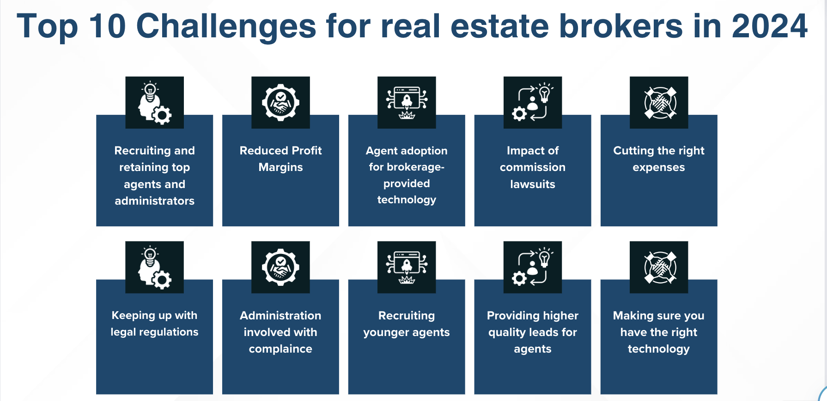

1. About Us

**Dalk kan hierdie stukkie eerder op die home page kom?**

**Where it all began**

**Our story begins with you!**

A business owner, grappling with the relentless changes in legislation and practices within the real estate industry. Amidst the multitude of challenges and loose ends, it's easy to lose sight of the dream that ignited the business journey. The joy and passion with which the business was founded can fade into a distant memory. But what if there was a way to navigate these challenges without feeling like you're running an endless marathon? Picture a scenario where the burdens of ever-changing legislation and operational challenges no longer overshadow the joy and vision you once had for your business. Our mission is to offer you relief from the daily grind, allowing you to refocus on what truly matters - building a profitable and flourishing enterprise.

**Mission**

To partner with businesses to help them unlock their true value. Helping them to sustain long-term profitability and build asset value businesses through overcoming challenges by creating space to focus on what truly matters.

**Our Values**

Customer Centricity

At BRE Consulting, we're firm believers that business success centers on people. With our clients at the heart of everything we do, we're dedicated to enhancing their customer service. Our tailored operations also prioritize your clients' needs, driven by professionalism and genuine care.

Excellence

Excellence is the cornerstone of operations at BRE. Our commitment is unwavering: to deliver nothing short of exceptional quality work and service in every task and interaction.

Integrity

At BRE, we pledge unwavering integrity in serving your clients. We promise to uphold your company's image and brand standards without compromise.

Passion

Fueled by a team of individuals deeply passionate about the real estate and service industry, you'll consistently encounter a warm, dedicated voice committed to delivering value to both you and your customers.

Teamwork

We're firm believers that teamwork is the cornerstone of exceptional service. Whether we're overcoming challenges or celebrating victories, we operate as one cohesive unit. Your success is our triumph.

Testimonials

Andries – Bow & Arc

Marna – Jubilee properties

1. Services
   1. Rental Administration

At BRE Consulting, we are at the forefront of transforming business processes for property practitioners and investors. Envision access to your own dedicated back-office team, but at a fraction of the cost. This team isn't just any group of professionals; they come with specialized expertise in the property industry, real estate administration, and relevant legislation. Our team's foundation is built on teamwork and passion, ensuring your business doesn't just survive but thrives, all while keeping costs down. The aim of BRE Consulting's administrative program is to liberate business owners from the shackles of time-consuming administrative duties, enabling them to concentrate on what truly matters: scaling their business. Discover the BRE Consulting difference for yourself and take the first step towards a more focused and streamlined business operation.

**Powerhouse Back-Office Team**

Your personal Attorney, Auditor, Accounts Manager and Administrator, all united under one roof. Say goodbye to the hassle of comparing between multiple service providers. Experience seamless communication and unparalleled unity across every facet of your business.

**Maintenance Management**

Our Maintenance Specialists stand ready to assist with your needs at any moment. Maintenance needs can arise unpredictably, often at the most inconvenient times. With our service, you gain access to an experienced maintenance managers available 24/7. The best part? You only pay for what you need, ensuring that you have expert support whenever necessary without the burden of fixed costs.

**Inspection Services**

Being a real estate agent, especially in the rental sector, involves a bustling schedule, with inspections playing a crucial role in the tenant placement process. These cannot be overlooked due to their importance. However, we understand the demands on your time, which is why we offer a dedicated inspectors to support you through every step of the inspection process. Our inspectors are specialized and trained to conduct thorough inspections, ensuring you avoid any complications with deposit deductions or legal issues. With our professional and meticulous approach, we guarantee no detail is missed. Following each inspection, you will receive a comprehensive inspection report, covering all the essentials you need to document.

* 1. Business Consulting

"Our business management consulting service ensures your business achieves its goals seamlessly. Weather you are looking to start your real estate venture or need assistance in growing and improving success faster, we have got you covered. BRE's business consulting services are expertly designed to guide your business toward achieving its objectives effortlessly.

**Business Plan & Start-up Consulting**

If you're gearing up to launch your own real estate enterprise or simply ready to take your business to new heights, look no further. Our specialized service ensures meticulous planning through the creation of a comprehensive business plan. From financial planning to navigating legal requirements and drafting the perfect mandate and lease agreement, we'll support you every step of the way, ensuring no crucial aspect is overlooked.

**Operational Consulting**

If you're observing gaps and inefficiencies in your team's operations, it may be time to realign roles and responsibilities. That's where we come in - offering a fresh, independent perspective to identify these gaps and address them with a tailored standard operating procedure report. Are you ready to optimize your processes and procedures for comprehensive coverage across the board?

**Compliance Consulting**

Now, more than ever, regulatory authorities are tightening property practitioners' obligations to comply with laws and regulations. Failing to adhere to these can lead to hefty fines and even imprisonment. Recognizing the challenges and administrative burden this presents, we offer a review service to identify areas of risk. We assist in assessing your compliance status and pinpoint where further implementation is necessary to avoid the consequences of non-compliance.

**Financial Consulting**

Our financial review service is designed to help you unlock all possible income streams, accelerating your path to greater profitability. Don't miss out on the opportunity to diversify your revenue streams and cut costs on unnecessary memberships and subscriptions.

**Technology Consulting**

In today's highly technologically advanced landscape, the multitude of software solutions available in the industry can often feel overwhelming when it comes to selecting the best option. Implementing and transitioning to new software can be a daunting and intensive endeavour, with the risk of realizing mid-project that it may not be the right fit, potentially resulting in significant financial losses. Fortunately, we possess extensive knowledge and experience with all the leading CRM and software solutions in the real estate sector, streamlining the decision-making process for you. Schedule a consultation with one of our specialists today, and let us guide you towards the optimal fit and solution for your specific needs, making the process easier and quicker.

**Value Proposition Pack**

In our all-inclusive package, you'll find eBook, PDF, and PowerPoint services designed to articulate your value propositions in writing. Through personalized and professionally branded presentations, we enable you to present with confidence and leave a lasting impression with your clients.

Blog & Events Page